Cell It: Board Game Edition

Design Problem

Currently in Year 8 Science the students are learning about cells and cell differentiation. While I am trying to use different methods of teaching, often I end up lecturing the students about cells. Chalk-and-talk methods of teaching content around cells are often boring and do not engage students. Many students prefer learning through interaction, including board games.

I need assistance in designing an age-appropriate board game which will engage students, is fun to play and will assist in educating year 8 students about cells.

The Engineering Design Process

In completing this project, you will use the Engineering Design Process. This was discussed in class (6/3) briefly and informally. A formal version of the process is outlined in following pages and can be found at https://www.sciencebuddies.org/science-fair-projects/engineering-design-process/engineering-design-process-steps#theengineeringdesignprocess

During the planning phase board games will be made available to test and investigate. For each game you play you will need to write some pros and cons. Before formal construction you will need to hand up a prototype of your game using paper and a short (½ page - 1 page) design brief outlining your game. During all phases dice, counters, jenga blocks and playing cards will be available to be used, along with any materials you bring in. The final game should be in a playable format and be able to be placed inside a box for travel/packaging.

You may also hand up a digital game or graphic novel/CYOA novel with negotiation. An Escape Room/alternate game for the Escape Room Chrono-Decoder would also be suitable.

Resources

Geek and Sundry: Board game reviews, hosts of International Table-Top Day, https://geekandsundry.com/

KickStarter: Crowd-funding for projects including board games, https://www.kickstarter.com/

The Game Crafter: Indie board game publishers, https://www.thegamecrafter.com/games

‘Stop Reading this and Go Make Your Own Board Game’: A guide to building board games, https://www.popularmechanics.com/culture/gaming/a11376/stop-reading-this-and-go-build-your-own-board-game-17314604/

Board Game Quest: Review site, https://www.boardgamequest.com/

Breakout Box EDU: A different type of Escape Room- literally build your own. Both Cendall and Myf have one and we may be able to borrow it, https://www.breakoutedu.com/

Escape Room The Game website: The official website for the Escape Room game https://escaperoomthegame.com/en-us/

Hasbro Board Game list: Monopoly, Game of Life… Hasbro make so many games, https://www.hasbro.com/en-au/brands/hasbrogames/search

The Different Types of Board game: Tells you what the different types of board games are, from co-operative through to RPG, https://nonstoptabletop.com/blog/2017/7/30/the-10-types-of-board-games-everyone-should-know-about

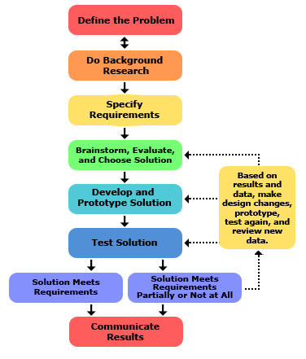
Figure 1: The formal engineering design process.

